Analysis Model for a Small B&B Reservation System

1. Use Case Model

a) Small B&B Reservation System Use Case Diagram
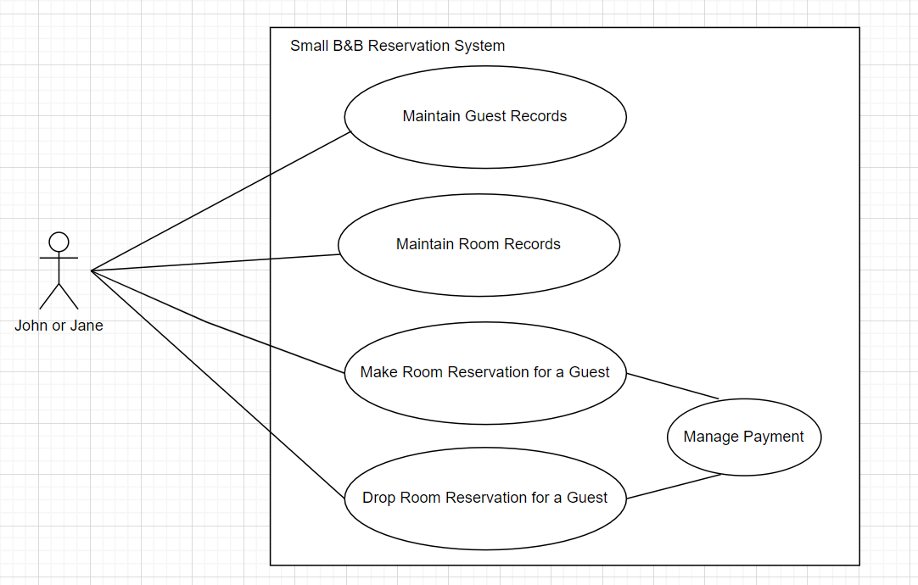

b) Sequence of Events (scenario) for Use Case: Make Room Reservation for a Guest

Upon receiving a call from a guest, John or Jane will make room reservation for the guest.

Preconditions:
Guest’s information is already in system including credit card numbers

Postconditions:
1) a reservation is made for the guest for the requested dates, or
2) no reservation is made

Sequence of events (scenario):
1) John or Jane askes the guest for the start and end dates for the requested reservation then enters the guest’s reservation requested start and end date into the system
2) The system displays a list of all available rooms during the requested date range and their corresponding prices. John or Jane informs the guest of the available rooms information
3) The guest selects one of the available rooms during the requested date range
4) John or Jane asks the guest for their name and completes the room reservation without or without a 1-day guarantee payment as agreed with the guest. Otherwise, if there are no available rooms on the selected date range or the guest does not like any of the available rooms, the use case starts all over again with a different start and end dates or no reservation is made

2. Class Diagram Model

a) Small B&B Reservation System Analysis Class Diagram
